TASK 4

Task 1

- Create a shell script to print the HTTP error code of guvi.in & print, the success/failure message based on the error code response

#!/bin/bash

# Enter the URl untill its get the input
#Using while loop infinite time to get output

while true; do

#get the URL -p

read -p "Eneter the URL" URL

#if it empty follow the if condition

if [ -z "$URL" ]; then echo "URL should not be empty"

else
break
fi

done

# Fetch the HTTP status code using curl
#$() = Whatever curl give (the status code) gets stored in the variable HTTP_CODE.

HTTP_CODE=$(curl -s -o /dev/null -w "%{http_code}" "$URL")

echo "HTTP Status Code: $HTTP_CODE"

# Check if the status code indicates success or failure
if [[ $HTTP_CODE -ge 200 && $HTTP_CODE -lt 300 ]]; then
echo "Success: The request was successful."
elif [[ $HTTP_CODE -ge 300 && $HTTP_CODE -lt 400 ]]; then
echo "edirection: The request was redirected."
elif [[ $HTTP_CODE -ge 400 && $HTTP_CODE -lt 500 ]]; then
echo "Client Error: Something went wrong with the request."
elif [[ $HTTP_CODE -ge 500 && $HTTP_CODE -lt 600 ]]; then
echo "Server Error: The server failed to handle the request."
else
echo "Unknown response."
fi
echo "Proce ID $$"

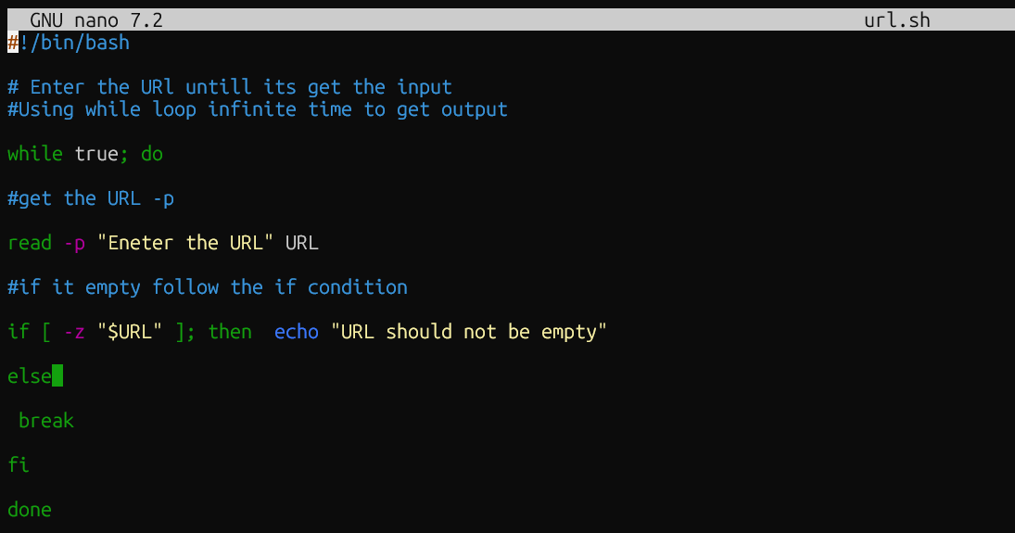
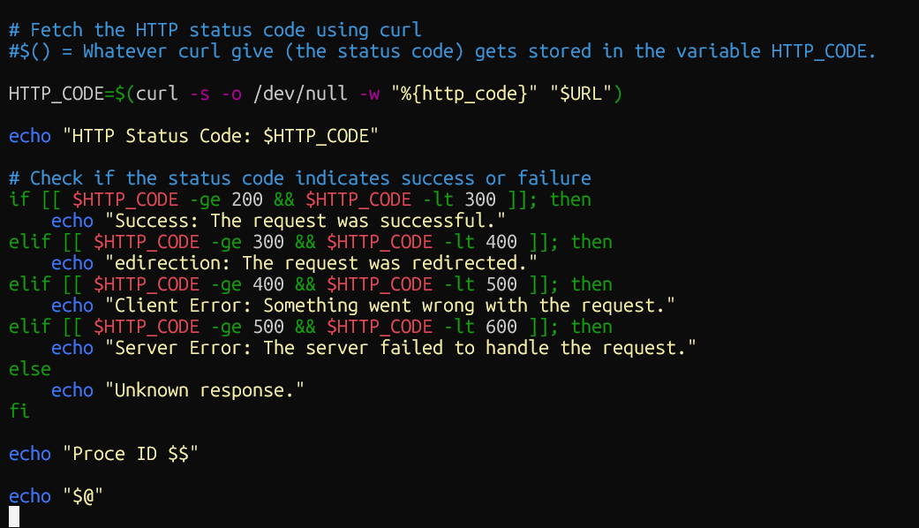

RESULT:
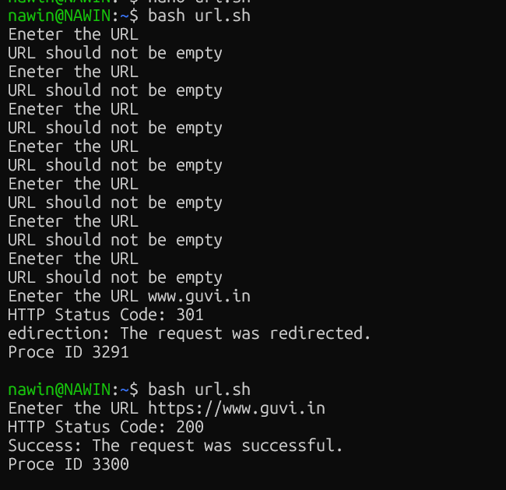

TASK2:

Given a file, replace all occurrence of the word "give" with "learning" from 5th line till the end in only those lines that contain the word "welcome"

